

**Summer Holiday Homework 2025-26**

**Class-VI**

**Subject- English**

**1.Make you pocket dictionary write five words of each alphabet (A to Z) with their meaning.**

**2.Write a paragraph(100 words) on n “How I spent my summer vacation”.**

**3.Learn and write following definitions with two example each .**

**(i) Noun(Add its Kinds) (ii) Common noun (iii) Proper noun**

**iv) Collective noun (v) Abstract noun**

**4.Make a list of 10 words each which have silent letter t,g and k in them.**

**विषय- हिन्दी**

1- प्रतिदिन एक पृष्ठ का सुलेख करो व पढ़ो।

2- संज्ञा,सर्वनाम,क्रिया,विशेषण,क्रिया-विशेषण की परिभाषा तथा पाँच-पाँच उदाहरणों का चित्रसहित उल्लेख करो।

3- विलोम शब्द (कोई दस) लिखो।

4- पर्यायवाची शब्द (कोई दस) लिखो।

5- निबंध लिखो व याद करो (कोई एक)

(क) अनुशासन का महत्व (ख) पर्यावरण प्रदूषण (ग) विद्यार्थी जीवन का महत्व

6 मुहावरे (कोई पाँच) लिखो व याद करो ।

**Subject- Sanskrit**

प्र०1 धाव् अथवा हस् धातु के रूप लट् और लृटलकार में लिखिए।

प्र०2- 15- पुल्लिंग शब्द, 15 स्त्रीलिंग शब्द और 15 नपुंसक लिंग शब्द लिखिए।

प्र०3- सभी स्वर और उनके प्रकार लिखिए।

प्र०4 निम्नलिखित शब्दों के वर्ण विच्छेद कीजिए।

सागर, तडाग, जलेबी, अरहर, चालाक, सुरभि

**Subject- Maths**

**Q1.Write and learn tables from 2 to 20.**

**Q2.Write squares from 1to 25.**

**Q3. Logical Reasoning and aptitude page – 236 to 238 Do question 1 to 25 in notebook.**

**Q4.Write a note about great mathematician of Indian with a picture on A4 sheet.**

**Q5.Define following with example-**

**(i)Angles (ii)Whole number (iii)Prime number**

**(iv)Odd number (v)Even number**

**Subject- Science**

1. Write 7 Scientist name with their invention.
2. 10 Terrestrial and 10 Aquatic animals and plants? (name&picture)
3. Draw a Balance diet diagram on A4 sheet
4. Write the examples of All nutrients [Carbohydrate,Protein,Fats,Vitamins and Minerals]
5. What is deficiency diseases and write about vitamins deficiency diseases.

**Subject S.S.T**

Collect pictures form magazines of different community helpers like doctors , teachers and shopkeepers, paste them on a chart paper label each picture and present it in class.

1. Fill in the missing seasons. Remember, the northern Hemisphere and the southern Hemisphere have opposite seasons(in your S.st book page no.11)
2. Make a time line of your life! Write the year in which each special event happened in your life. If you cannot remember, ask your parents.
3. Draw the following latitudes on the given circle(in your map book page no.11)

(a)Tropic of cancer 23 ½ N (b)Tropic of copricorn 23 ½ S

(c)Arctic circle 66 ½ N (d)Antarctic circle 66 ½ S

1. Draw the following on an outline map of world.(in your map book page no.19)

(a)Tropic of cancer (b)Tropic of copricorn

(c)Arctic circle (d)Antarctic circle

**6. Answer the following questions-**

(1)The largest continent and its area.

(2)The smallest continent and its area.

(3)The largest ocean and its area.

(4)The name of the ocean named after India.

(5)The deepest point in the pacific ocean and its depth.

(6)Make a chart on the topic “ Solar System”.

(7)What do you understand by monuments?

(8)What is history?

(9)Write something about “ Unity in Diversity”.

**Subject- Computer**

**1.**Explain the components of the CPU.Take help from the data given on page no .12-13 of the work on the practical file.

2.Find and paste pictures of at least 8 input devices and 8output devices with name.

3.Name the first computer programmer.

4.Write the shortcut key in keyboard (maximum 30).

5.Write the full form in computer (maximum 30).

6.Draw the diagram: computer parts on the chart paper and label it.

**Subject- G.K**

**Q1.Name 15 Countries name and their capitals.**

**Q2.Draw and colour an Indian flag write significance of each colour.**

**Q3.Find and write 5important news headlines related with (sports science, politics or Entertainment) write from the last month newspaper.**

**Q4.Name 5 leafy vegetables.**

**Q5.Write the capital of states in India.**

**Q6.Write short notes on any there famous Indian personalities. (Freedom fighters, scientists, or sports persons)**

**Subject- Drawing**

1- Draw given calligraphy on A-4 sheet and decorate it with colours.

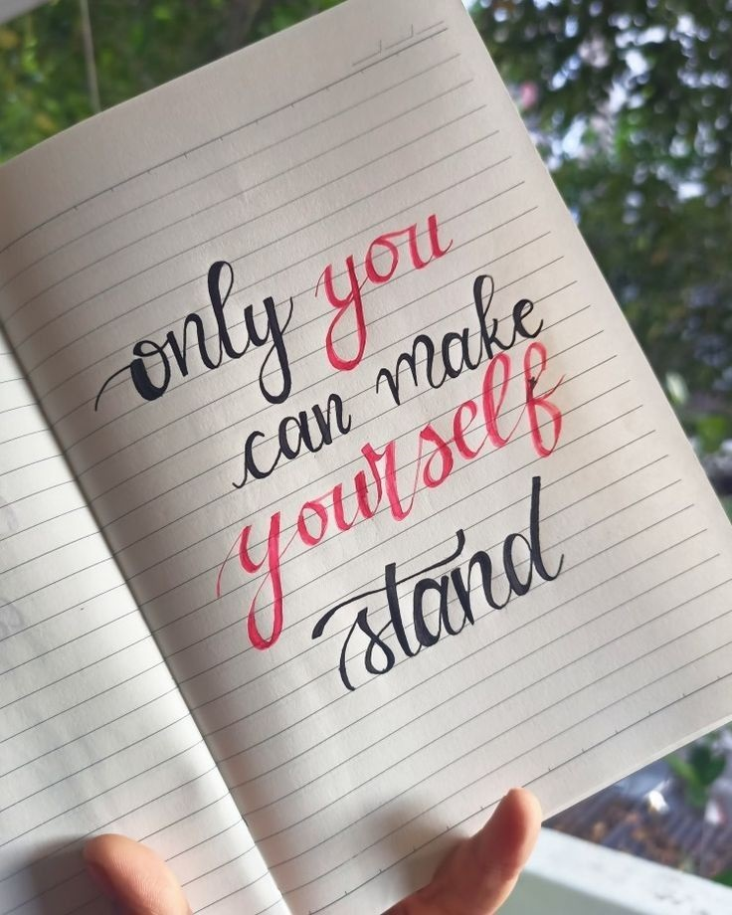

**Creativity corner :-**

**Prepare a Father’s day card, give it to your father and take a short video or pictures.**

1- Father' day Celebration on 15 June 2025

**Prepare a short video or take pictures related to any one activity**

1- Environmental day Celebration on 5 June 2025

2- Use any recyclable material like - plastic , bottle, cardboard boxes, old C.D and make any craft material

3- Reuse rain water

4- Plant any indoor or outdoor plant in your house

5- Any ecofriendly activity to save mother earth.

6- Implant Any seed in soil and observe its growth.

**Perform any one activity and prepare a short video or take some pictures.**

1- International Yoga day Celebration on21 June 2025

2- Surya namaskar

3- Tadasana (Mountain Pose)

4- Vrksasana (Tree pose)

5- Bhujangasana (Cobra Pose)

6- Paschimottanasana (seated Forward bend)

**Note – (i) Revise the syllabus covered so far in every subject.**

**(ii) Use your subject notebook to solve question.**

**iii) 5 marks will be awarded in each subject in Periodic test-II for completing the holiday homework.**